Bharat Intern-

Stock Prediction

import numpy as np

import pandas as pd

import matplotlib.pyplot as plt

from sklearn.preprocessing import MinMaxScaler

from sklearn.model_selection import train_test_split

from keras.models import Sequential

from keras.layers import LSTM, Dense

# Load the stock price data

df = pd.read_csv('bharat_intern/all_stocks_5yr.csv')

# Get the closing prices

data = df['Close'].values.reshape(-1, 1)

# Normalize the data

scaler = MinMaxScaler()

data = scaler.fit_transform(data)

# Split the data into training and testing sets

train_size = int(len(data) * 0.8)

train_data = data[:train_size]

test_data = data[train_size:]

# Function to create time series dataset

def create_dataset(data, time_steps=1):

    X, y = [], []

    for i in range(len(data) - time_steps):

        X.append(data[i:(i + time_steps), 0])

        y.append(data[i + time_steps, 0])

    return np.array(X), np.array(y)

# Set the time steps for LSTM

time_steps = 60

# Create the time series dataset

X_train, y_train = create_dataset(train_data, time_steps)

X_test, y_test = create_dataset(test_data, time_steps)

# Reshape the data for LSTM (samples, time steps, features)

X_train = np.reshape(X_train, (X_train.shape[0], X_train.shape[1], 1))

X_test = np.reshape(X_test, (X_test.shape[0], X_test.shape[1], 1))

# Build the LSTM model

model = Sequential()

model.add(LSTM(units=50, return_sequences=True, input_shape=(X_train.shape[1], 1)))

model.add(LSTM(units=50))

model.add(Dense(units=1))

# Compile the model

model.compile(optimizer='adam', loss='mean_squared_error')

# Train the model

model.fit(X_train, y_train, epochs=10, batch_size=32)

# Evaluate the model

train_loss = model.evaluate(X_train, y_train)

test_loss = model.evaluate(X_test, y_test)

print("Train Loss:", train_loss)

print("Test Loss:", test_loss)

# Make predictions

train_predictions = model.predict(X_train)

test_predictions = model.predict(X_test)

# Inverse the normalization

train_predictions = scaler.inverse_transform(train_predictions)

y_train = scaler.inverse_transform([y_train])

test_predictions = scaler.inverse_transform(test_predictions)

y_test = scaler.inverse_transform([y_test])

# Plot the results

plt.plot(y_train.flatten(), label='Actual Train')

plt.plot(train_predictions.flatten(), label='Predicted Train')

plt.plot(len(y_train.flatten()) + np.arange(len(y_test.flatten())), y_test.flatten(), label='Actual Test')

plt.plot(len(y_train.flatten()) + np.arange(len(y_test.flatten())), test_predictions.flatten(), label='Predicted Test')

plt.xlabel('Time')

plt.ylabel('Stock Price')

plt.legend()

plt.show()

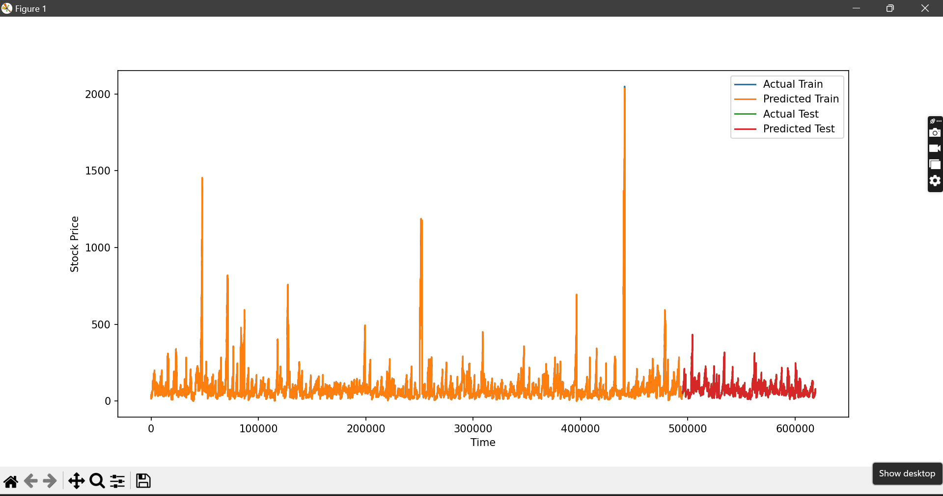

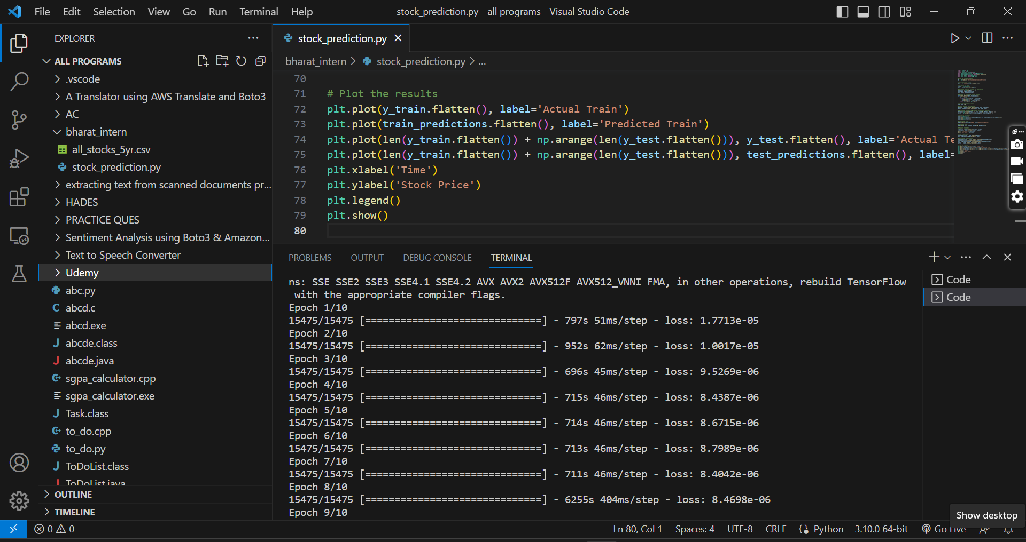

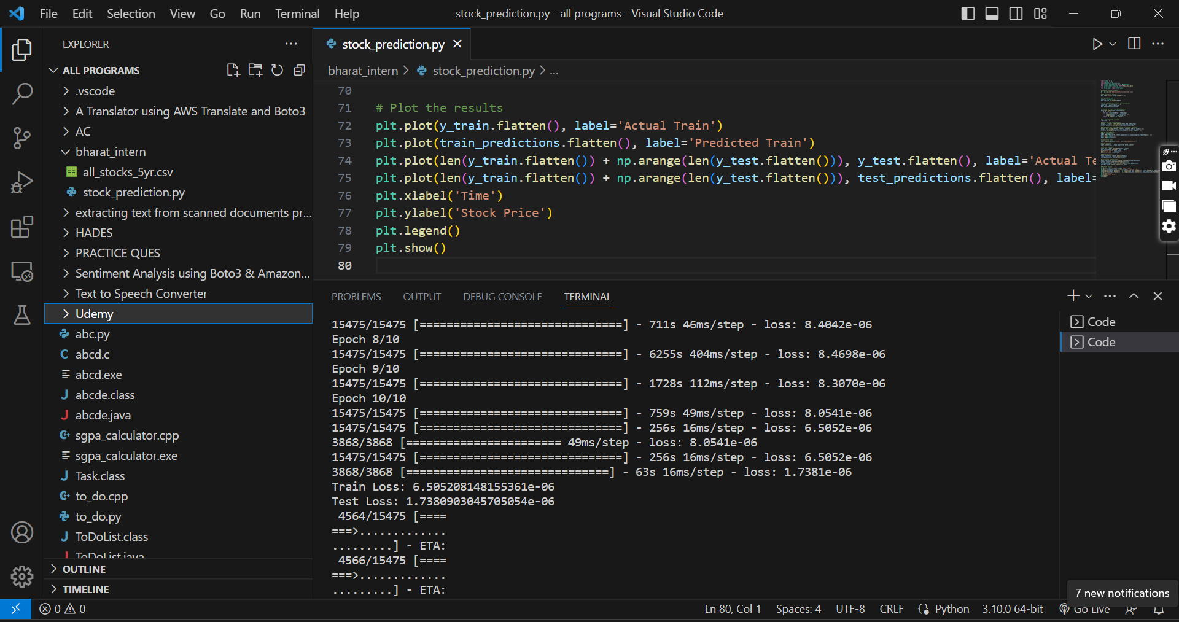

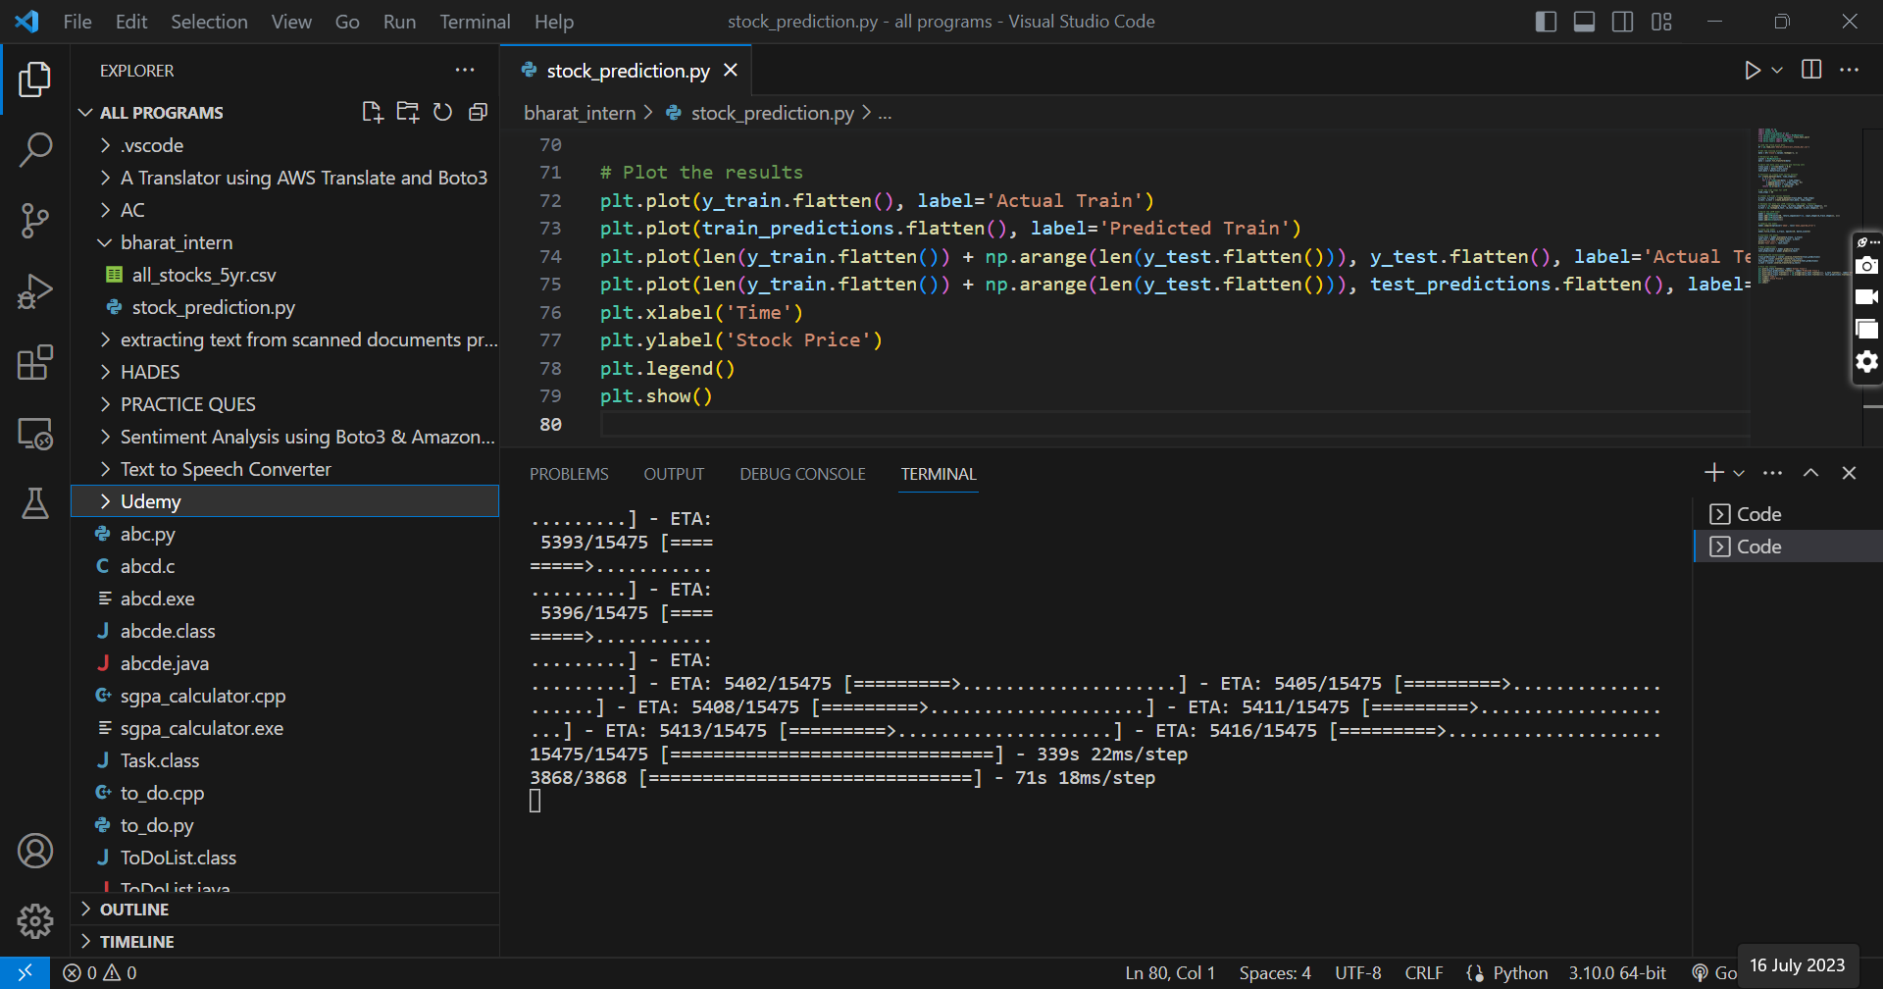

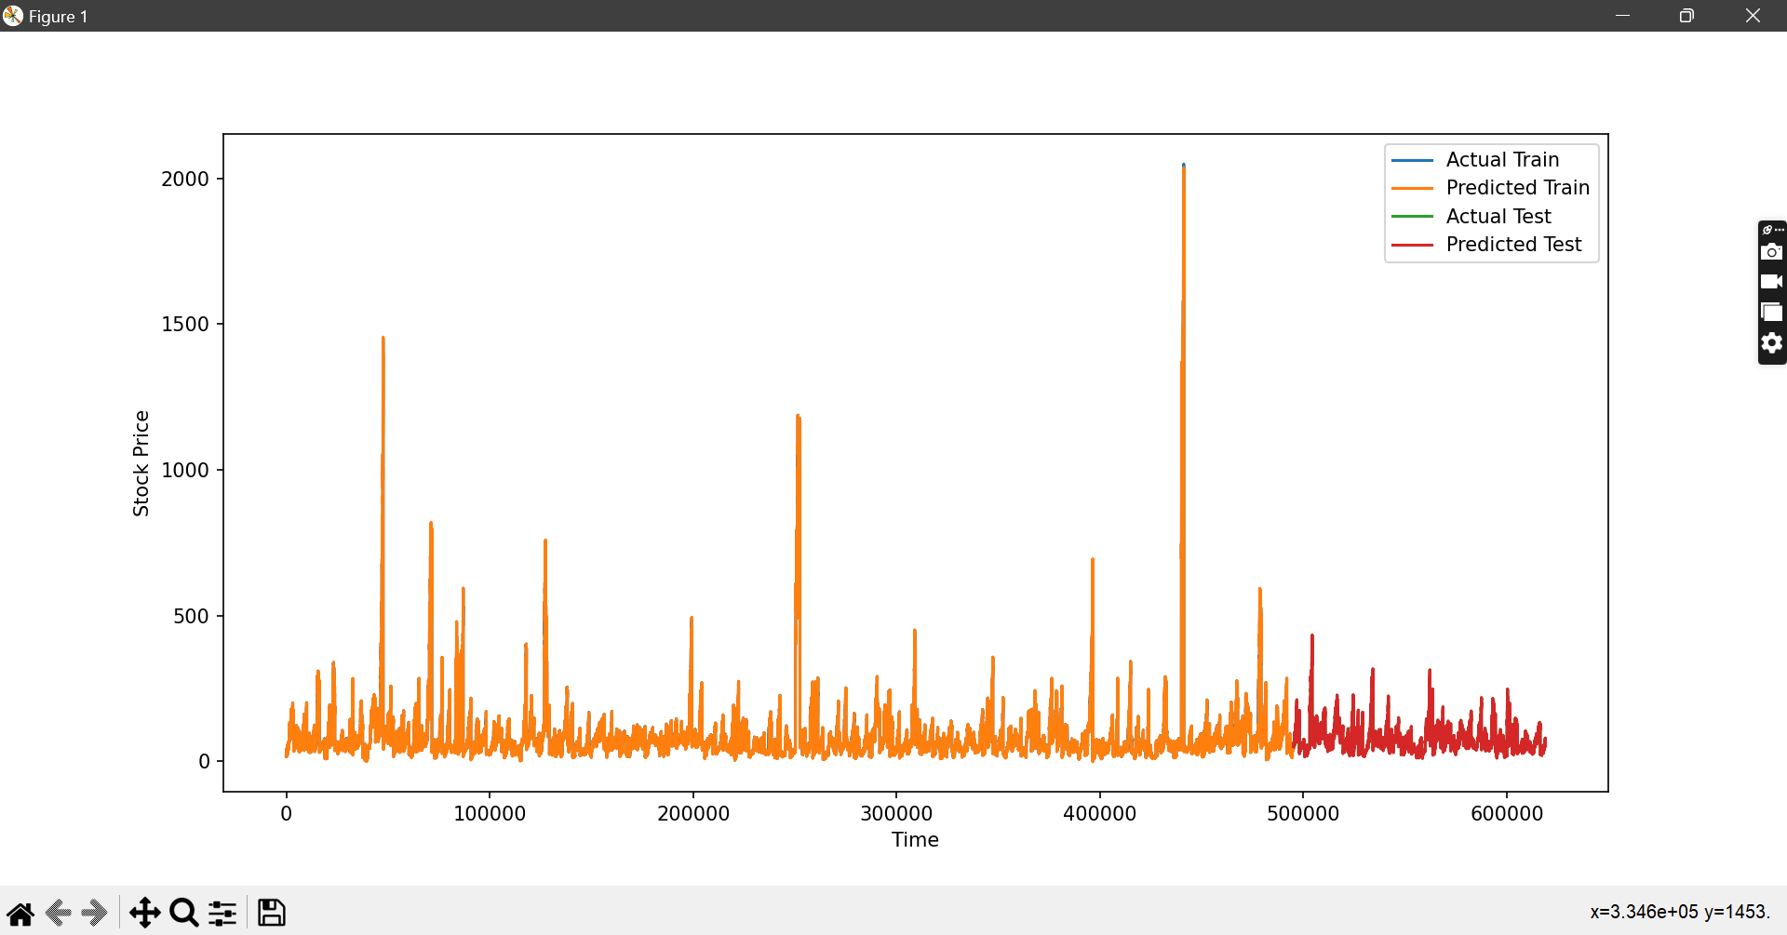

Text Classification-

# Import necessary libraries

import pandas as pd

from sklearn.model_selection import train_test_split

from sklearn.preprocessing import LabelEncoder, OneHotEncoder

from sklearn.ensemble import RandomForestClassifier

from sklearn.metrics import accuracy_score

# Load the Titanic dataset

data = pd.read_csv('bharat_intern/titanic_train.csv')

# Select relevant features and target variable

features = ['Pclass', 'Sex', 'Age', 'SibSp', 'Parch', 'Fare', 'Embarked']

target = 'Survived'

# Preprocess the data

data = data[features + [target]].dropna()  # Remove rows with missing values

data['Sex'] = LabelEncoder().fit_transform(data['Sex'])  # Convert 'Sex' to numerical

# Encode 'Embarked' column using one-hot encoding

embarked_encoded = pd.get_dummies(data['Embarked'], prefix='Embarked')

data = pd.concat([data, embarked_encoded], axis=1).drop('Embarked', axis=1)

# Split the data into training and testing sets

X = data.drop(target, axis=1)

y = data[target]

X_train, X_test, y_train, y_test = train_test_split(X, y, test_size=0.2, random_state=42)

# Train the model

model = RandomForestClassifier()

model.fit(X_train, y_train)

# Predict the survival outcomes

y_pred = model.predict(X_test)

# Calculate the accuracy of the model

accuracy = accuracy_score(y_test, y_pred)

print('Accuracy:', accuracy)

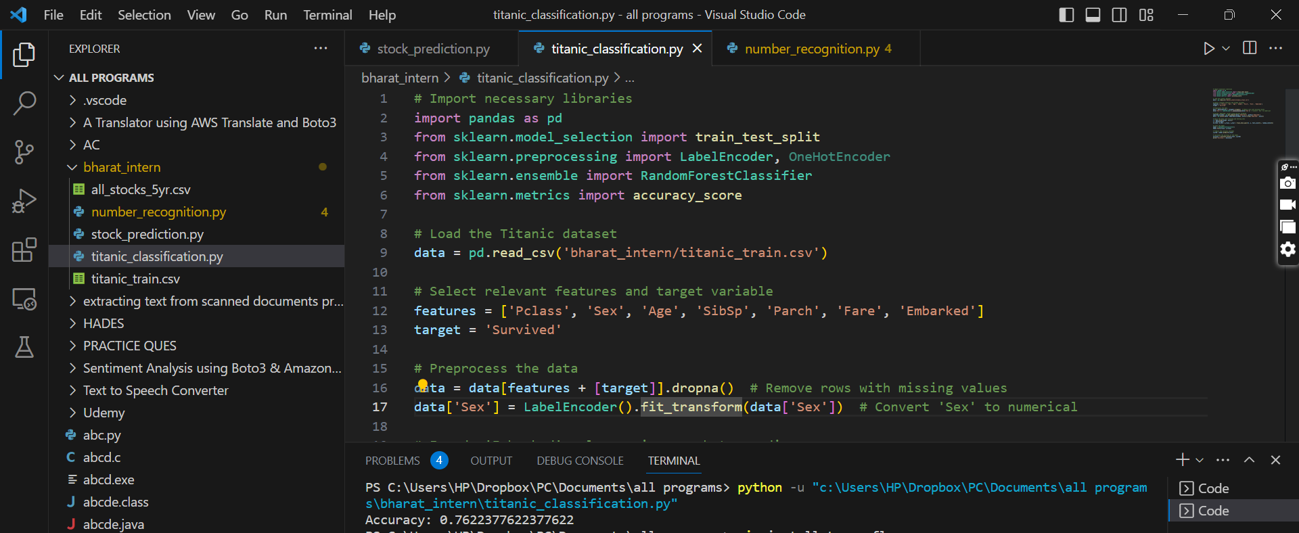

Number Recognition

# Import necessary libraries

import tensorflow as tf

from tensorflow.keras.datasets import mnist

from tensorflow.keras.models import Sequential

from tensorflow.keras.layers import Dense, Dropout

from tensorflow.keras.utils import to_categorical

# Load the MNIST dataset

(X_train, y_train), (X_test, y_test) = mnist.load_data()

# Preprocess the data

X_train = X_train.reshape((60000, 784))  # Flatten the images (28x28 pixels) into a single vector

X_test = X_test.reshape((10000, 784))

X_train = X_train.astype('float32') / 255.0  # Normalize pixel values between 0 and 1

X_test = X_test.astype('float32') / 255.0

y_train = to_categorical(y_train)  # Convert labels to one-hot encoded vectors

y_test = to_categorical(y_test)

# Build the neural network model

model = Sequential()

model.add(Dense(512, activation='relu', input_shape=(784,)))

model.add(Dropout(0.2))

model.add(Dense(10, activation='softmax'))

# Compile the model

model.compile(optimizer='adam', loss='categorical_crossentropy', metrics=['accuracy'])

# Train the model

model.fit(X_train, y_train, epochs=10, batch_size=128, verbose=1)

# Evaluate the model

_, accuracy = model.evaluate(X_test, y_test, verbose=0)

print('Accuracy:', accuracy)

